**MATHEMATICS SPECIALIST UNIT 3&4 Name_______________**

**TEST 1, 2016**

You must show all working

**Section One: Resource Free**

Time: 22 minutes Total marks: 22 ________________________________________________________________________________________

1. [5 marks]

State if the following equations below are functions. For those that are functions state their natural domain.

a) 

b) 

c) 

2. [1, 1, 1 marks]

Using the function below as y=f(x)

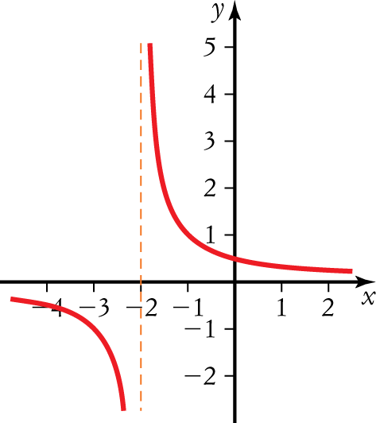

a) Sketch y=|f(x)| on the set of axes. b) Sketch y=f(|x|) on the set of axes.



c) Sketch  on these axes



3. [2, 2, 3 marks]

Let  and . Determine

a) the defining rule for 

b) the range of .

c) the value of .



4. [2 marks]

Sketch the graph of f(x)=|x-1|+1

on the axes

5. [5 marks]

Sketch the graph of  ,showing all important features.



**MATHEMATICS SPECIALIST UNIT 3&4 Name_______________**

**TEST 1, 2016**

You must show all working

**Section Two: Resource Rich**

Time: 20 minutes Total marks: 20 ________________________________________________________________________________________

6. [1, 2, 1, 2 marks]

The graphs of  and  are shown below over their respective domains.



a) Determine

(i) .

(ii) .

b) Determine

(i) the range of .

(ii) the domain for which  is defined.

7. [5 marks]

For each graph below that shows a function, on the same axes sketch the inverse function. For those that do not show a function, clearly indicate which graph(s) and briefly give your reasoning in the space below the graph.



8. [2, 2, 2, 3 marks]

a) Solve , giving your solution(s) in terms of .

b) The graphs of  and  are shown below.



(i) Solve .

(ii) Solve 

(iii) Given that the solution to  is , determine all possible values for  and .